***Does Mecklenburg County have a housing availability and affordability issue?***

Based on the specific housing findings, my data points towards yes. Over the past 5 years the cost of home ownership has increased while home ownership itself has decreased. On top of that, income levels have barely increased when you take into account inflation. Thirdly, there appears to be a significant lack of housing inventory. All these factor into the Mecklenburg County availability and affordability problem.

***Are poverty levels going up or down?***

To answer this question, we utilized data found on datausa.io for Mecklenburg County (<https://datausa.io/profile/geo/mecklenburg-county-nc>). Specifically, we used the poverty and gender datasheet they had on their website. The first order of business was to clean up the data to make it usable. We decided it would be more appropriate to use data for people 18 and over, as there are considered legal adults. After cleaning up the age demographics, we went to work analyzing the data. We split the age groups up into six different ranges - 18-24, 25-34, 35-44, 45-54, 55-64, 65-74, and 75 and over. What we found was that for ages 54 and younger, the total poverty numbers decreased from 2013-2018. For the 55 and over crowd, the total poverty numbers actually increased during the same time period. If we had more time, we would have liked to have gone back and done regression analysis between rental prices and total poverty numbers. (Two example graphs below)

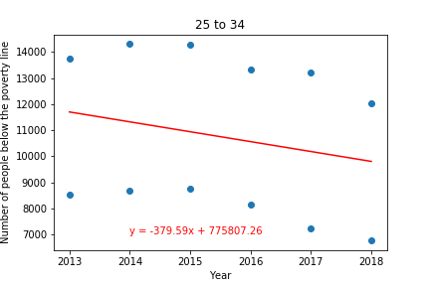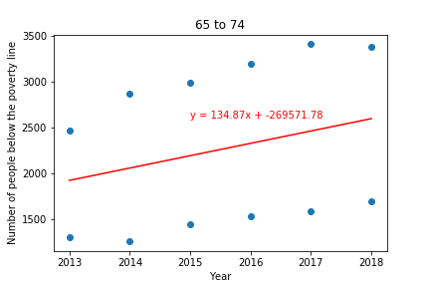

***Homelessness in North Carolina - Houston, do we have a problem?***

In driving around Charlotte, I see homeless people at various street corners asking for help. Seeing these people makes me wonder *… Why are these people homeless? Where do they go at night if they are homeless? What happened to them that brought on their homelessness? How long have they been ‘living’ like this? Are there programs and services to help these people? What can I do to help some of these people?* And a plethora of other questions come to mind. *Does Charlotte have a homelessness problem?* In searching for data to answer this question, I ran into a brick wall.

The dataset that I was eventually able to locate only drilled down as far as the state level, nothing specifically available about Charlotte or Mecklenburg County. The dataset I used in my graphs came from the Department of Housing and Urban Development: [*https://www.hud.gov/2019-point-in-time-estimates-of-homelessness-in-US*](https://www.hud.gov/2019-point-in-time-estimates-of-homelessness-in-US)

The file is a large excel workbook with separate sheets for each year from 2019 back to 2007. Each sheet contained a row for each state and over 500 columns of data on homelessness in those states. In my exploration and clean up process, I ran out of time in trying to use pandas to consolidate the original data set to just data for North Carolina for the most recent years. I chose to create a new Excel spreadsheet, copy and paste the row data for North Carolina into this new Excel spreadsheet and limit the columns to 8 columns about homelessness overall. I then read that new Excel spreadsheet into my jupyter notebook as a csv file. I used matplotlib to create my graphs based on the information in this much condensed data set.

The graphs tell a surprising story about homelessness in NC. After looking at this data, I am left with more questions. What factors impacted the sharp decrease in homelessness in North Carolina seen from 2013 through 2017? Is this decrease in homelessness seen in North Carolina reflected in other states? If so, which states and why? What is causing the increase in homelessness we have seen since 2017? These are the questions I would explore if given more time on this project.

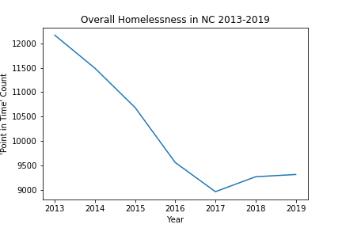

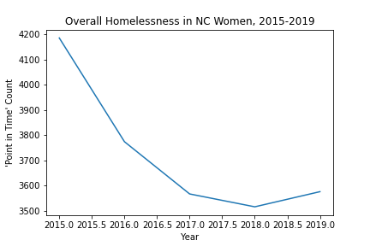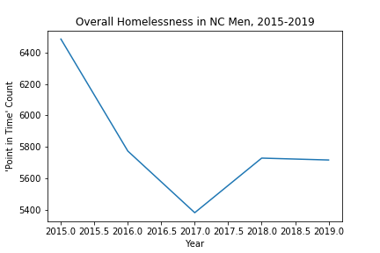

***What are Rental prices in Charlotte--and are they affordable?***

Utilizing the Charlotte Open Data database we found current rental prices for apartments and houses throughout Mecklenburg County. The data was cleaned by dropping rows of data that did not have rental data in it, after we cleaned the data, we were able to manipulate and add additional formulas to find the information we were seeking. We found the median amounts for each bedroom to find how much they cost. Then to better view the actual price we divided the rental price by the number of bedrooms to find the price per bedroom. By doing this we were able to conclude that prices between 1 bedroom and 5 bedrooms overall aren’t that far apart, just a few hundred dollars different. However, when looking at price by bedroom this is where we see the discrepancy. It is much cheaper for a person to live in a 4 or 5 bedroom place with roommates to split rental costs than it is to live in a 1 bedroom. The graphs below properly display this information.

